# Table of Contents

5_24_update.zip - File Update as of May 24th

5/27 - Driving Times

5/28 - SVI and Population

5/28 - Other Symbology Notes

# 5_24_update.zip - File Update as of May 24th

* **0_5_mile_walking -** 0.5 mile Euclidean distance buffer around each store location to be used for walking
  + 0_5_mile_convenience – for all the convenience stores
  + 0_5_mile_food_service - for all food service locations
  + 0_5_grocery - for all grocery stores
  + 0_5_sells - for all locations that sell fresh produce

The endings apply to the rest of the distances

(Sells - for all locations that sell fresh produce)

* **0_25_mile_walking -** 0.25 mile Euclidean distance buffer around each store location to be used for walking
* **1_mile_walking -** 1-mile Euclidean distance buffer around each store location to be used for walking
* **2_mile_biking -** 2-mile Euclidean distance buffer around each store location to be used for biking
* **3_mile_biking -** 3-mile Euclidean distance buffer around each store location to be used for biking
* **4_mile_biking -** 4-mile Euclidean distance buffer around each store location to be used for biking
* **5_mile_biking -** 5-mile Euclidean distance buffer around each store location to be used for biking

**Border_style_and_bus_route_line**

* Border style - just the borders of the two counties
* Bus route line - given to us by Hannah, had all the bus routes of the Benton Franklin transit system

**Transit_stops_1_mile**

* 1 mile Euclidean buffers around the individual transit bus system stops that are within 1 mile of each store location for the selected location (grocery, convenience store, grocery or other that sells fresh produce, and food service)

# 5/27 - Driving Times

**Driving Times:**

Due to issues with ArcGis, then QGIS, then later in Python, using the network distances to get a more specific read on the situation is going to have to be later workshopped in Python since that just plain wasn’t working

(I hit the limit in terms of credits, yes that is a system in ArcGIS, for network analysis. Meaning that my neat polygon based on the roads would not be able to be calculated that way). QGIS has a plug in that isn’t quite accurate the way I wanted it to be, so I have been trying to make a program in Python instead.

All that being said, this means that the current files are a very rough estimate of 10 minute driving distance and are there simply to be there. They follow the same name notation as the others, and are geoJSON files.

(sells = Grocery and other stores that sell fresh produce)

(con = convenience stores)

(grocery = grocery store)

(food service = restaurants and other miscellaneous establishments)

I am aware that they look fairly lame right now.

# 5/28 - SVI and Population

**Index_Pop.zip -**

**Contains both the (Economic Social Vulnerability Index) & the percentages of the population by Census tract.**

I realize that there isn’t a way to preserve symbology in a .geoJSON file, so I wrote out how to do so for both below. Please tell me if I can save you time by helping with the code.

If this will take too much time to include the Index, in that case, I insist on the percent population by Census tract to be included, because then the rest of the map doesn’t make too much sense without it (you can’t compare the areas that most need more locations that sell fresh produce without seeing where most people live).

**SVI -** contains an index I calculated based on the 2020 estimated Census rates for 9 different variables that are most relevant to the context of this project (ex: it doesn’t make too much sense to include # of people under age 17 or # of people in municipalities when the variable doesn’t indicate if these are for example, the really expensive apartment buildings with a million amenities).

**There are two rows that need to be labeled as “No Data” in both the SVI and the % Population. They have suppressed values for some reason, and no amount of searching on the Census page led me to find out what could be used for them, which is why I took a while with it.**

These two rows are labeled:

* FIPS column values for both:
  + 53021980100
  + 53005012000
* Additionally, in both geoJSON’s they’re the only rows with 0 values in the Pct_total or the IndexFinal columns.

## Appearance of the Extras:

**Social Vulnerability Index:**

* Would be transparent as a layer, (this is set at 50%, but if it needs to be bumped down even more, go for it)
* Put underneath all the other layers
* The two fips codes would appear grey for no data
* Using the Index column

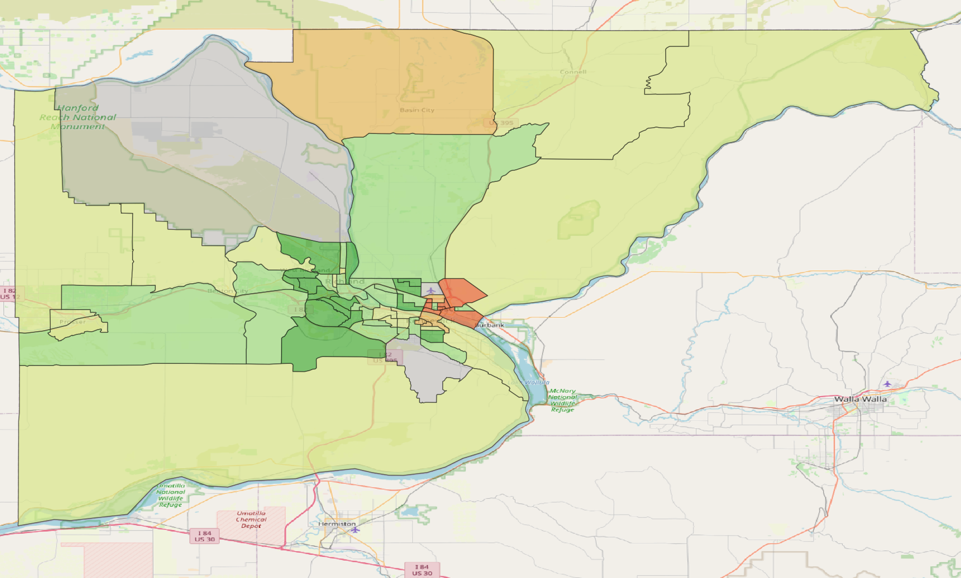

**HexCodes Used in order from top to bottom of the image, numbers used in terms of the categorization**

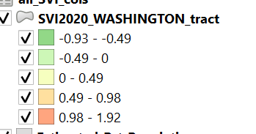

1. #825264
2. #9cf06f
3. #eeff7f
4. #ffc340
5. #ff4d00

**Legend Labels (the one on the very right would appear on the widget for the website), ignore the middle column, values clarified below in the other table**

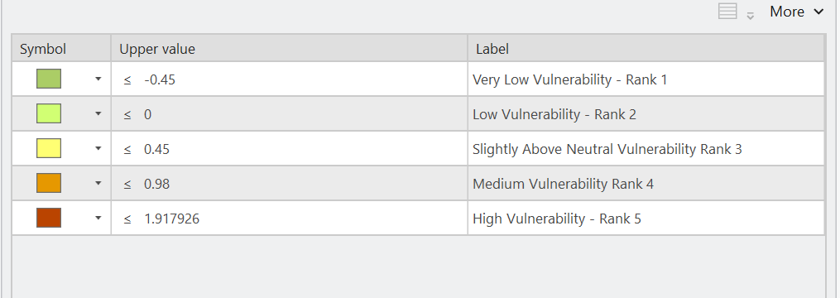

| Value to code into symbology | Label for Use (SVI) |
| --- | --- |
| -0.92 to - 0.49 | Very Low Vulnerability - Rank 1 |
| (-0.49) to 0 | Low Vulnerability - Rank 2 |
| 0 to +0.49 | Medium-Low Vulnerability - Rank 3 |
| 0.49 to 0.98 | Medium Vulnerability - Rank 4 |
| 0.98 to 1.9179 | High Vulnerability - Rank 5 |

**Grey - no data**

**Estimated Percentage of Population**

* Same thing as the last one,
* should be 50% transparent and below all the other layers
* Using the Pct_total_ column this time
* Not entirely sure which would look better with our existing color choices, provided hex codes for both
* The two “No Data” FIPS codes should still be labeled as such in grey, my bad

Option 1 -

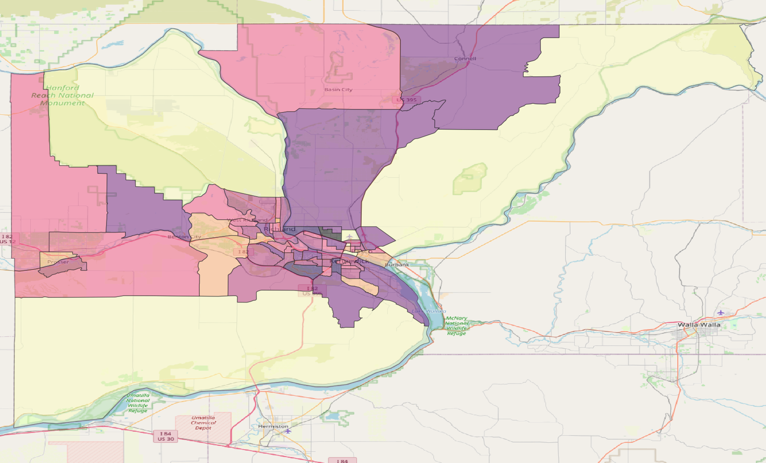

Option 2 -

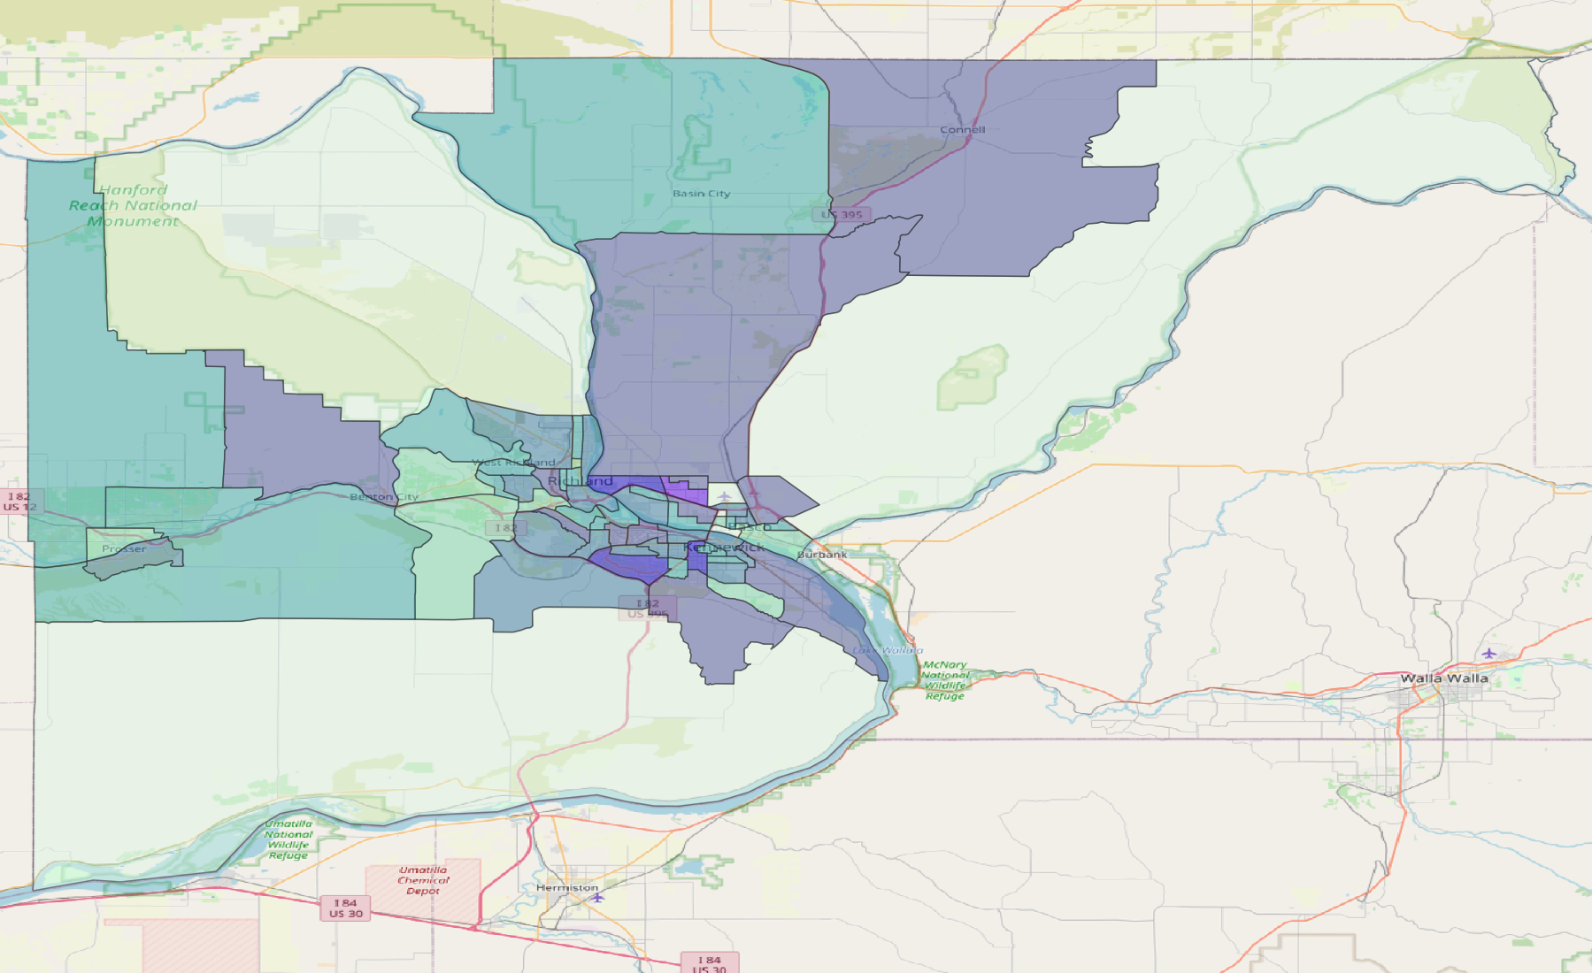

| Value to code into symbology | Label for Use (Estimated Percentage of the Total Population) |
| --- | --- |
| 0.0 - 0.5 | < 0.5% |
| 0.51 - 1 | 0.5% - 1% |
| 1.01 - 1.5 | 1% - 1.5% |
| 1.51 - 2 | 1.5% - 2% |
| 2.01 - 2.5 | 2 - 2.5% |
| 2.5 - 3 | 2.5% - 3% |
| > 3 | > 3% |

Option 1 (Blues, slightly edited “Mako” on QGIS

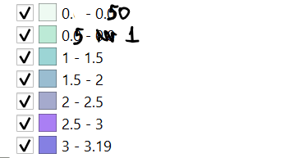

1. #def5e5
2. #7ad6ae
3. #39abac
4. #357ba3
5. #4b559b
6. #0c02c8
7. #5600ea

Option 2 (instagram colors I guess, slightly edited “Magma” on QGIS) -

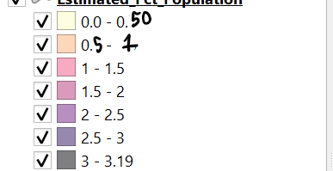

1. #fcfdbf
2. #feaf78
3. #f15687
4. #b6367a
5. #721f81
6. #2d115f
7. #000004

# 5/28 - Other Symbology Notes

* ~~Was reading what Alyson wrote for us, I do agree that the green on the biking is confusing when the base map is also green. Some other color should be used here (maybe a blue grey color that’s less saturated than the waling)~~
* ~~Similarly, the yellow of the driving also blends into the base map and is hard to see, would change that entirely either to a grey, or violet, or something with more contrast.~~
* ~~The red of the transit with the lines looks good, but with the SVI is going to blend in too much, again, maybe it should be somewhere on the blue/violet/grey scale~~
* ~~I’m also confused about the filtering, I thought that I had separated all the layers so that they weren’t combined according to category.~~
  + ~~But radii for unselected categories are appearing? I guess it’s fine if that is what we submit, I was just unclear~~
  + ~~If that’s how we’re submitting the final map, then I request that the 15-minute polygon I managed to get done with the road networks on ArcGIS before I ran out of credits is used instead.~~
* Everything looks good! I’d say we can leave the base requirements as they are.